lOMoARcPSD|275

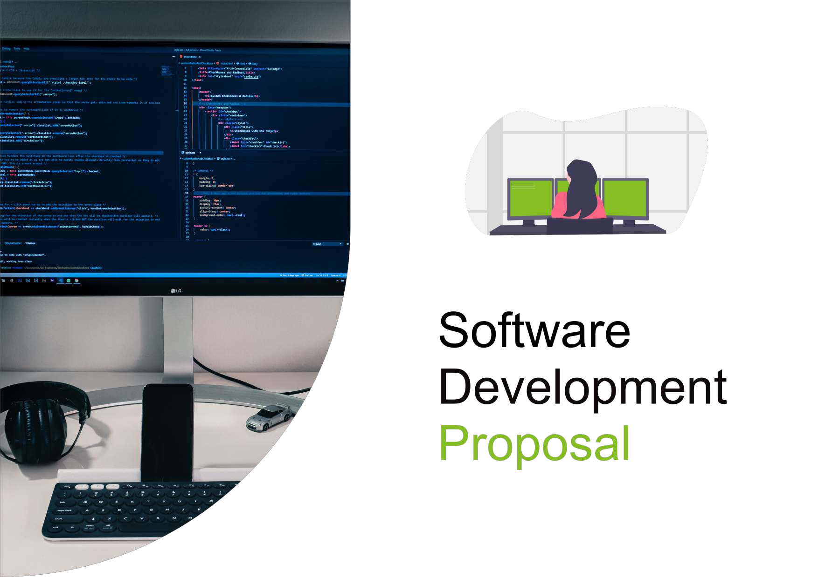

Software Development Proposal

1



# Overview

Our proposal to you from Deloitte is a private, internally authenticated monitoring system for the 9 items of heavy machinery in operation across the 4 global *Daikibo Industrials* locations. This software will relay and summarize machine statuses live to you in the form of a simple and accessible dashboard using the telemetry data you can already supply. Overall, we believe this proposal will suit the current needs of your business and will optimize your productivity and product output by quickly and effectively identifying which machines and locations which most critically require your attention.

2

# Scope

The dashboard’s clean drop-down list format is able to fit onto one screen. This minimizes clutter and allows you to efficiently see machine health on a factory-wide or specific machine level and where any issues may lie, without having to dig for the information you seek. The inclusion of machine health history provides you with a machine’s history of uptime and downtime, which can be utilized as a measure of its reliability and condition (if it has had numerous issues within an unreasonable amount of time). Furthermore, by knowing how much time a machine takes to be repaired, your time resources in future can be optimized.

3

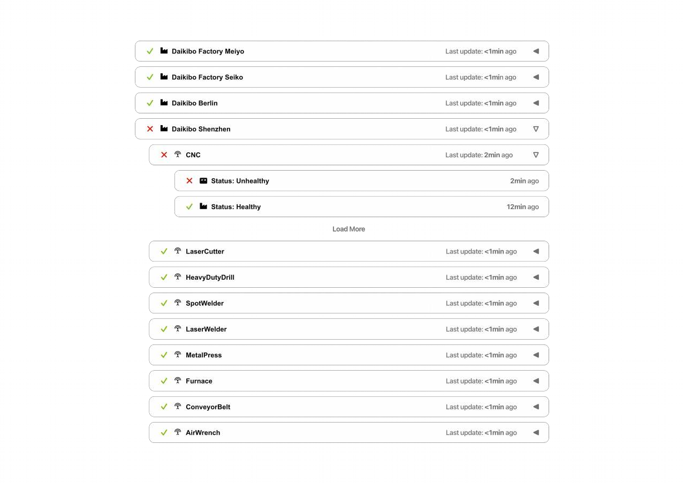

4

# Estimate

The development targets entail the coding and creation of the webpage in- cluding all necessary features and the user interface. The testing targets in- volve the process of running the soft- ware, either with the client’s Intranet system or with our (Deloitte’s) own to ensure it works without any issues by identifying errors in programming or with compatibility between the software and its host. Finally, the integration tar- gets are included to ensure that after this webpage has been developed and properly tested on several occasions, it can be fully and properly installed into your Intranet, ready for use. In total, we estimate that the complete develop- ment, testing and integration of this so- lution will take about 178 – 200 working hours.

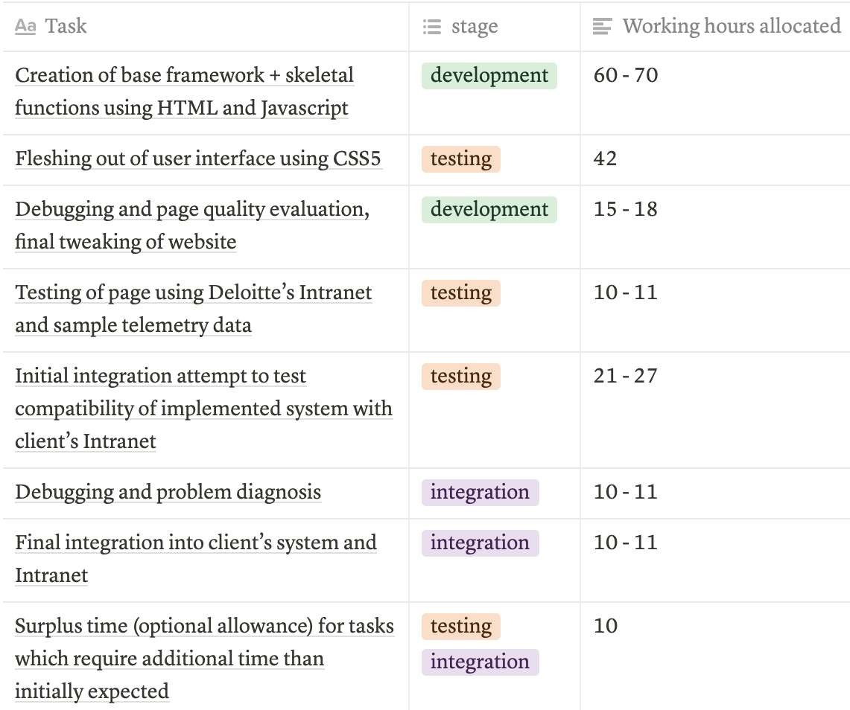

# Timeline

1. [1st of September, 2021] **Design starts**
2. [1st – 10th of September, 2021] **Creation of base framework + skeletal functions using HTML and JavaScript**
3. [11th – 18th of September, 2021] **Fleshing out of user interface (UI) using CSS5**
4. [19th – 22nd of September, 2021] **Debugging and page quality evaluation, final tweaking of website code**
5. [22nd – 25th of September, 2021] **Testing of page using Deloitte’s Intranet and sample telemetry data**
6. [25th – 30th of September, 2021] **Initial integration attempt to test compatibility of implemented system with client Intranet**
7. [1st – 3rd of October, 2021] **Debugging and problem diagnosis**
8. [4th – 7th of October, 2021] **Final integration into client’s system and Intranet**

* 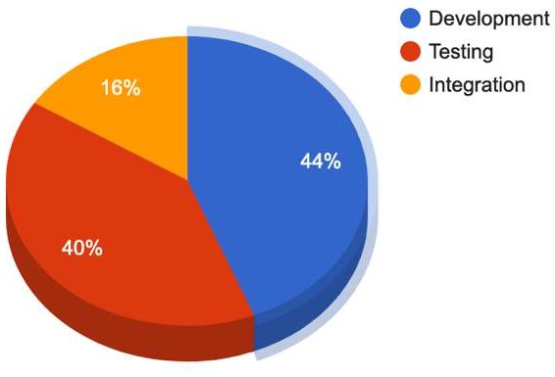**[Surplus time (optional allowance for tasks which require additional time than initially expected]**

6

# 5. Support

For urgent issues you face on a daily-weekly basis, you can call us at Deloitte if you run into basic software issues and require a technician to examine the problem, and we will have the issue fixed within an estimated 1 – 3 business days. Quarterly, Deloitte will email a selected head member of Daikibo Industries from each location and request any feedback you may have about the system, or any improvements you would like to see in the software. The continuous chain of feedback which you provide will help ensure our solution’s longevity as a part of your businesses and factories by adapting to any changes you make or encounter. Yearly, we propose a board meeting with a selected head member from every Daikibo Industries factory, and/or a member who uses our software to have a more formal and thorough face-to-face discussion about the solutions we have in place for you. This yearly meeting will allow us to have a consistent point of contact to touch bases about problems and issues with your software or other important areas you think Deloitte is able to assist you with. We hope these support methods are adequate to maintain and upkeep the product which we will create for you.

7